Introduction and Purpose
The International Bank for Reconstruction and Development (IBRD) has tasked our working group with producing a generalized predictive model for life expectancy across the world. The client requested that we choose 5 different variables to include in our models, they also requested that we explore 3 different models and determine which one has the best fit. Our analysis drew data from Gapminder, a dataset containing data on 194 different countries.
Variables
Response Variable: Life Expectancy (measured in 2025).
Predictor Variables: Overall access to basic sanitation (2024), child deaths (2022), food supply in kilocalories per person per day (2022), murders (2023), and whether the country had a female head of state (2021).
Data Preparation
We sourced five raw datasets from the Gapminder website, and one dataset from the base r library (but still from Gapminder). Datasets were cut down to show only the desired year and then combined into one master dataset using the country code as a matching key (meaning that our programming language identified which rows to combine across raw tables based on the three letter country code consistent across all datasets).
Two of our variables were not yet scaled to country size in the data, child deaths and murders were in raw numbers, and not per capita or rates per 100,000 people. This meant that we needed to scale the two variables to enable comparison across different sized countries. This was done by dividing each value by 100,000 to reach a scaled or comparable value. Additionally, our categorical value, female head of state, was in worded form (yes/no). To include this categorical value in our modeling we needed to convert each value to a number (1 = yes, 0 = no).
Modeling
We chose three different models. The first (Model1) was a bivariate regression predicting the response variable using only the overall access to basic sanitation predictor. Our Second model (Model2) was a multivariate model using overall access to basic sanitation and food supply as predictors. And the third (Model3) was another multivariate model using access to sanitation, murders, child deaths, and the binary female head of state predictors.

Results
Our predictor variables in models 1 and 2 all produced statistically significant results (p < 0.001). In model 3, though food supply and female head of state both showed to have statistically insignificant results (p > 0.05). We determined that the second model (model2) provided the best fit due to its highest adjusted r squared value (r^2 = 0.710), meaning that 71% of life expectancies variation could be explained by the model, and its lowest residual standard error (RSE = 3.77) (the average amount that life expectancy strayed from the predicted regression line or model line) compared to the two other models.
Question
Is there a relationship between child deaths and food supply?
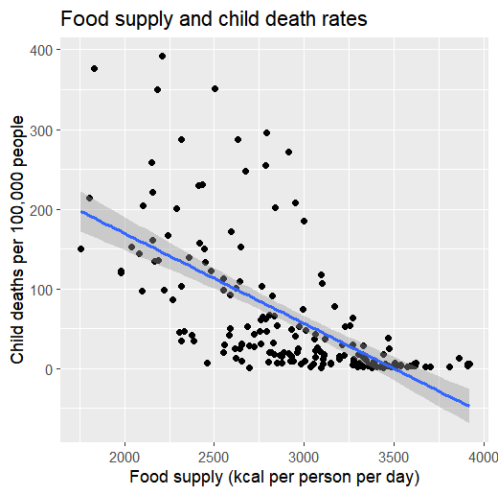
Answer:
There is a statistically significant negative association. The fitted model estimates that an additional 100 kilocalories per person per day is associated with about 11.3 fewer child deaths per 100,000 people. Food supply explains about 41% of the variation in child-death rates ($R^2 = 0.412$). This is an association, not proof that food supply causes lower child mortality.

